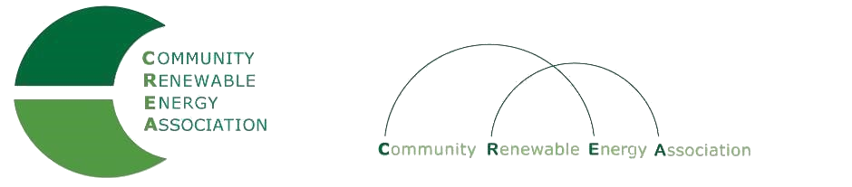
www.community-renewables.com

Community Renewable Energy Association Annual Meeting
Tuesday, November 19, 2019, 10:00 a.m. to 1:00 p.m.
Wilder/Hansberry Room
The Graduate Hotel, Eugene, OR

1. Call to Order 10:00 – 10:15
– Don Russell, CREA Chair
- Welcome and introductions of members and invited participants
- Changes to the agenda

2. CREA Business Meeting 10:15 – 10:45
– Don Russell, CREA Chair, and Rob Bovett, CREA Legal Counsel
- Review and approval of minutes
- Review and approval of financial report

3. Election of Executive Committee Members 10:45 – 11:15
– Rob Bovett, CREA Legal Counsel

4. Energy Planning Matters: Why Local Governments Should 11:15 – 12:00
Take an Active Role in their Energy Future
– Commissioner Les Perkins, Hood River County

5. Working lunch: Open Q&A and Discussion Energy and Utility Issues 12:00 – 1:00
– Don Russell, CREA Chair
- Why we do what we do: Fighting for energy-related tax base and jobs
- Open forum for discussion of energy and utility issues

Agenda packet attachments: CREA Executive Committee Roster (1 page) Page 2
CREA Intergovernmental Agreement (4 pages) Pages 3 - 6
CREA Bylaws (6 pages) Pages 7 - 12
CREA Minutes from October Meeting (2 pages) Pages 13 - 14
CREA Financial Reports (11 pages) Pages 15 - 25

