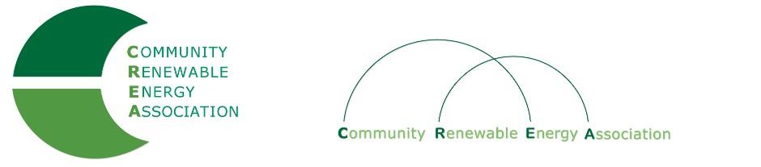
http://community-renewables.org

CREA Membership Application
Industrial Business
COMPANY INFORMATION:

Company:____________________________________________________________________
Adress:_______________________________________________________________________
City:__________________________State:_________________________Zip:______________
Contact Person:___________________________Phone:_______________________________
E-mail:_______________________________________________________________________
_________________________________INDUSTRY__________________________________
Manufacturer Developer Legal Installer Financial Irrigation Other

Company Interests:_____________________________________________________________
_______________________________ TECHNOLOGY_______________________________
Wind Hydro Solar Biomass Geothermal Wave Other (Check all that apply)

______________________________MEMBERSHIP TYPE____________________________
Small Industry Large Industry Individual Sponsorship
Sales < $1m/yr Sales > $1m/yr Members Gift
Dues $100 Dues $500 Dues $50 $_________________

__________________________ADDITIONAL INFORMATION______________________
Member names, special information, etc.

________________________________APPLICANT NAME___________________________
Name: Date:

Title:_________________________________________________________________________
Please send completed form and check or money order to: Community Renewable Energy Association
c/o Mid-Columbia Council of Governments
1113 Kelly Ave.
The Dalles, OR 97058

