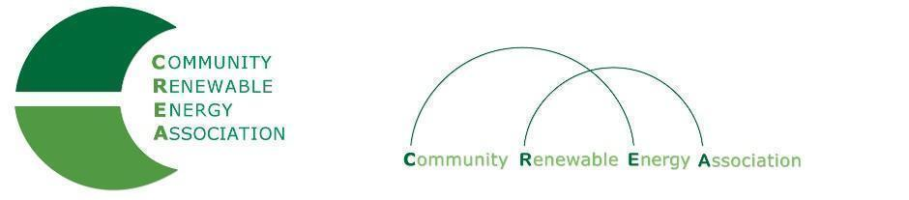
www.community-renewables.org

Executive Board Agenda
Friday, September 10, 2021: 10am-1:00pm
Via Zoom Video Conference:
https://us06web.zoom.us/j/83451192173?pwd=WGlrSmNqdjdrL0FmejVyTVJXU3pkQT09
Meeting ID: 834 5119 2173
Passcode: 451147
Find your local number: https://us06web.zoom.us/u/kcXlKI1ZNh

- Call to Order/Open Agenda - CREA Executive Chair, Commissioner Perkins
- Roll Call/Introductions/Time set aside for issues not presented on the agenda

- Consent Agenda – Chair Perkins
- Approve Minutes: August 13, 2021
- Accept Financials for August, 2021
- Accept Audit

- Old Business: Program for CREA Annual Conference

4. Representative Smith: Depot Project - 10:30

5. Solar Siting Discussion: AOC Support - Director McArthur - 11:00

6. Nick Smith (Lake County Resources Initiative) - 11:30

7. Appointments to ODOE Advisory Groups - Director McArthur
- Small Scale Study
- Development Fund

8. October 8 CREA Mtg. Boardman? - Director McArthur

9. Public Comment - Chair Perkins

(See Page 2 for additional Agenda items to include an Executive Session)

10. Executive Session (12:45pm)

Executive session pursuant to ORS 192.660(2)(h) to consult with counsel concerning the legal rights and duties of a public body with regard to current litigation or litigation likely to be filed.
The purpose of this executive session is for the Executive Committee to consult with CREA Legal Counsel with regard to possible action by CREA in relation to pending litigation.
IMPORTANT NOTE: After the executive session, the Executive Committee is likely to return into open session to further discuss the matter, and possibly take action.

11. Return to Open Session (12:55)

Possible decision regarding pending litigation.

12. Adjourn - Chair Perkins

