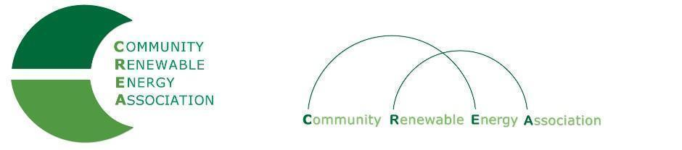
www.community-renewables.org

Executive Board Agenda
Friday, February 10, 2023: 10am-1:00pm Via ZOOM
Join Zoom Meeting
https://us06web.zoom.us/j/85657127703?pwd=VkNpcHhUNUdFYjRjMjUwTUFKOVg4UT09
Meeting ID: 856 5712 7703
Passcode: 697695
Find your local number: https://us06web.zoom.us/u/kc37NZBMFl

- Call to Order/Open Agenda - CREA Executive Chair, Commissioner Perkins
- Roll Call/Introductions/Time set aside for issues not presented on the agenda

2. Consent Agenda – Chair Perkins 10:00am
- Approve Minutes: January 20, 2023
- Accept Financials for January, 2023

4. Designation of Exec Committee Alternates

5. HB 2416 - Req: large electricity users to comply with reqs to use renewable energy 10:15am
- Robert Echenrode, (General Manager, Umatilla Electric Coop)

6. Reports & Discussion of Legislative Issues - Tess Milio/Mike McArthur 10:30am

7. Renewable siting Issues - Jeff Fox (Gallatin Power) 11:00am

8. Legislative Positions - Tess Milio/ Mike McArthur 11:30am

9. Introducing Allie Detrio (Microgrids Coalition) - Allie Detrio 12:30pm

10. Public Comment/Next Meeting - Chair Perkins

11. Adjourn - Chair Perkins 1:00pm

* Next Meeting: March 10, 2023: In Person? Location? Prineville?

