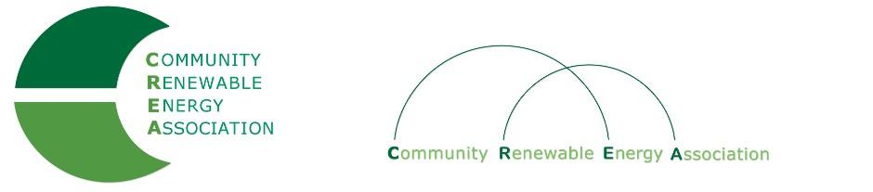

CREA Membership Application
County/City/Govt. Entity

EntityName:__________________________________________________________________
Address:______________________________________________________________________
City:__________________________State:_________________________Zip:______________
Contact Person:_________________________________________Phone:_________________
E-mail:_______________________________________________________________________

_______________________________Type of Energy _________________________________
Geothermal Biomass Solar Wave Wind Other:
_________________

_______________________MEMBERSHIP TYPE (* = county paying $20,000 SIP)_______ Cities Cities Counties Counties Counties Counties Counties
Pop. Pop. Gen in Co. Gen in Co. Gen in Co. Gen in Co. Gen in Co.
>50,000 <50,000 0 MW up to 10 MW 10.1 - 50 MW 50.1 - 101 MW* 101 MW*
$250/yr $500/yr $250/yr $1,500/yr $2,500/yr >$20,000 SIP <$20,000 SIP

* Payments are contained through SIP Agreements

__________________________ADDITIONAL INFORMATION______________________
(Member names, special information, etc.)

_____________________________________________________________________________

________________________________APPLICANT NAME___________________________
Name: Date: ______________________________________________________________________________
Please send completed form and check or money order to: Community Renewable Energy Association
802 Chenowith Loop: The Dalles, OR 97058

Contact email: admin@community-renewables.org

* Irrigation Districts follow the same generation/dues model as Counties.

